**DAILY ONLINE ACTIVITIES SUMMARY**

|  |  |  |  |  |  |  |  |  |
| --- | --- | --- | --- | --- | --- | --- | --- | --- |
| **Date:** | **10-6-2020** | | | | | **Name:** | **Likhitha.M** | |
| **Sem & Sec** | **6th sem ‘A’** | | | | | **USN:** | **4al17cs046** | |
| **Online Test Summary** | | | | | | | | |
| **Subject** | | **System Software and Compiler Design** | | | | | | |
| **Max. Marks** | | **30** | | **Score** | | | **28** | |
| **Certification Course Summary** | | | | | | | | |
| **Course** | **Introduction to Ethical Hacking** | | | | | | | |
| **Certificate Provider** | | | **Great learning** | | **Duration** | | | **3 days** |
| **Coding Challenges** | | | | | | | | |
| **Problem Statement:**  1.Write a C Program to print the sum of boundary elements of a matrix  2. Write a Java program to find the maximum and minimum value node from a circular linked list  3. Python Program to check whether a given number is a fibonacci number or not | | | | | | | | |
| **Status: completed** | | | | | | | | |
| **Uploaded the report in Github** | | | | | **yes** | | | |
| **If yes Repository name** | | | | | **https://github.com/likhithaMantaral/Daily-status** | | | |
| **Uploaded the report in slack** | | | | | **yes** | | | |

Online test Details:

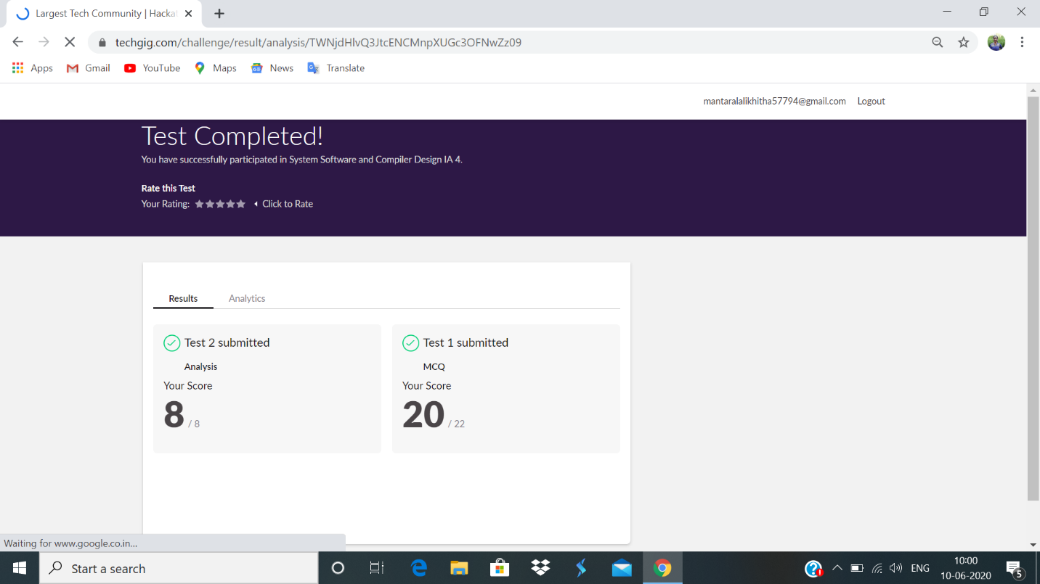

Certification Course Details:

**Ethical Hacking on Mobile Platforms- Demonstration**

Android Operating System

Linux based mobile device operating system. The core android source is known as Android open source project (AOSP).

Android Debug Bridge:

ADB is versatile command- line tool that lets you communicate with a device.

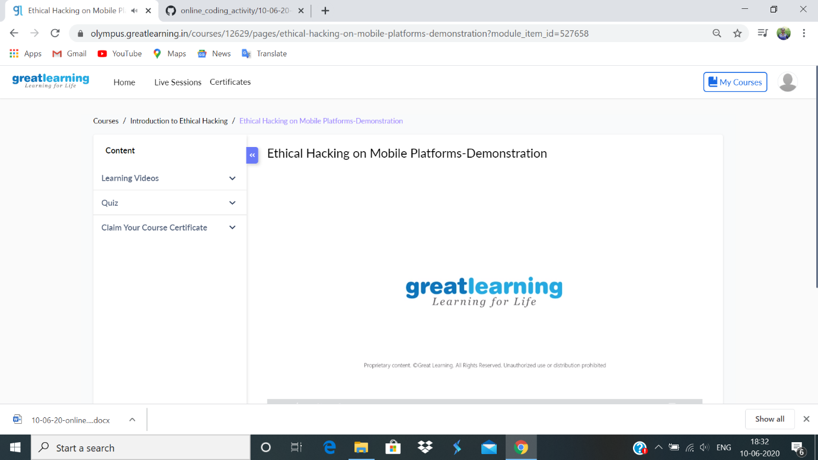

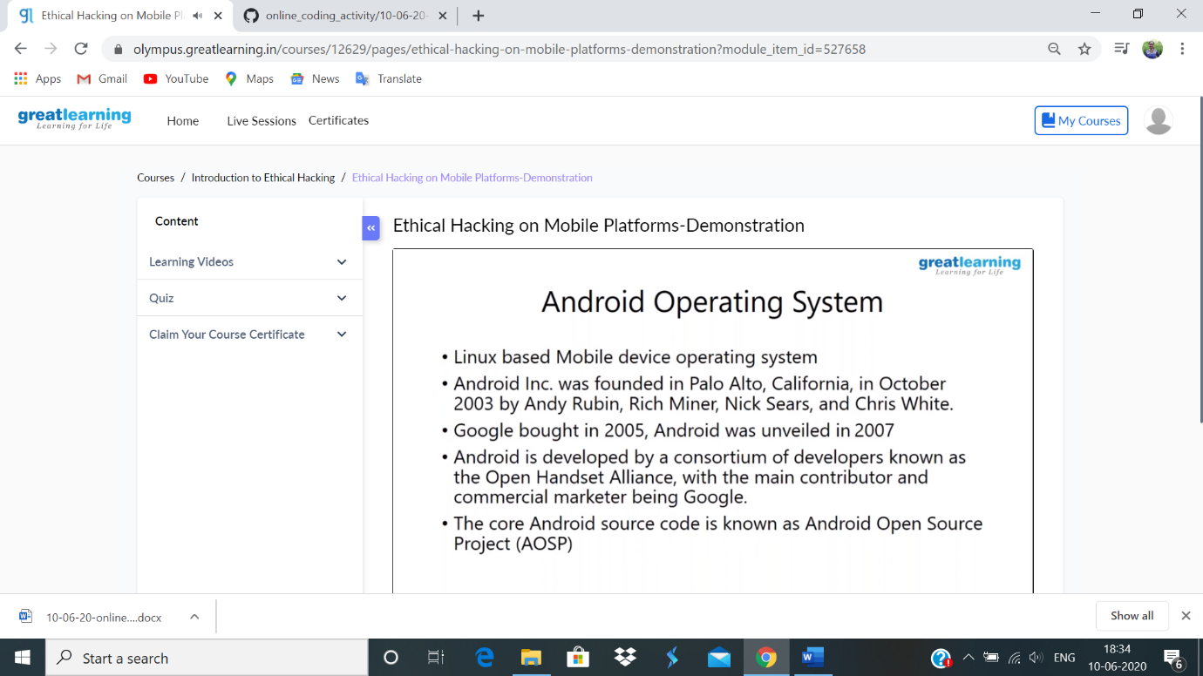

**Coding challenge:**

**1.**

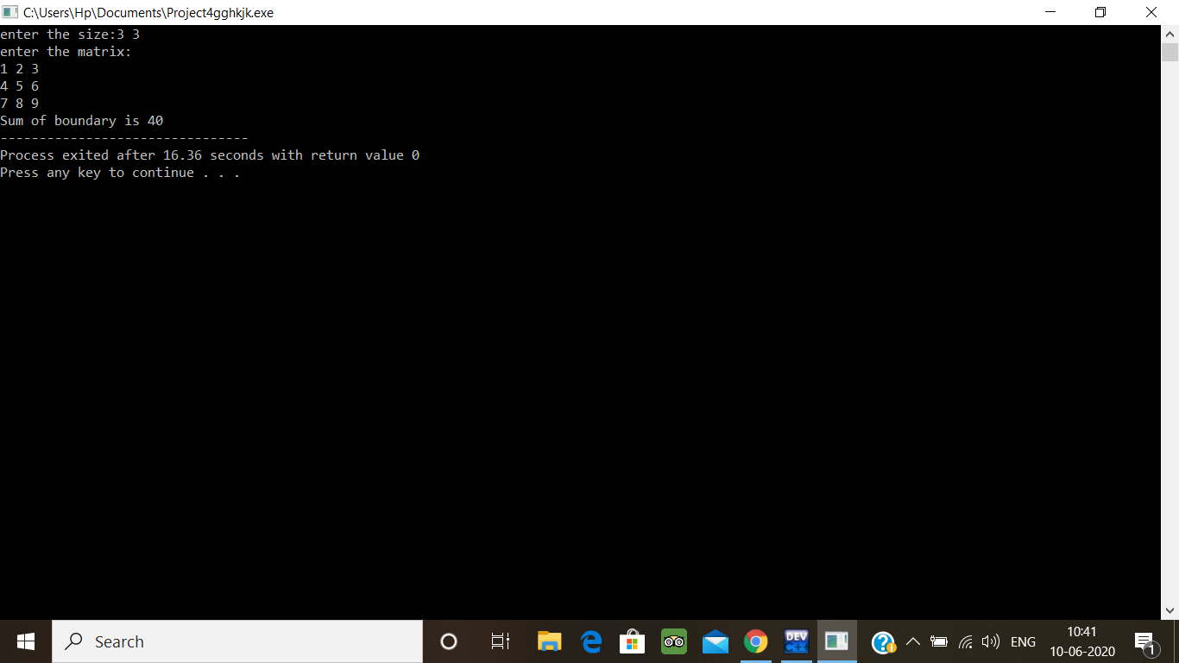

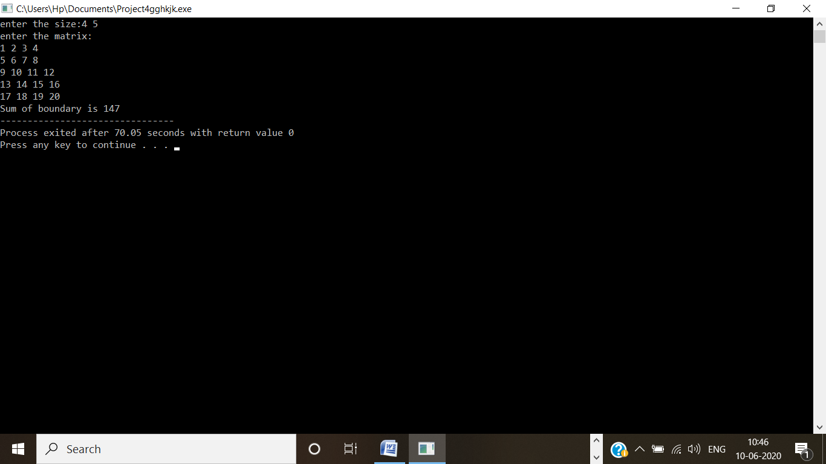

2.

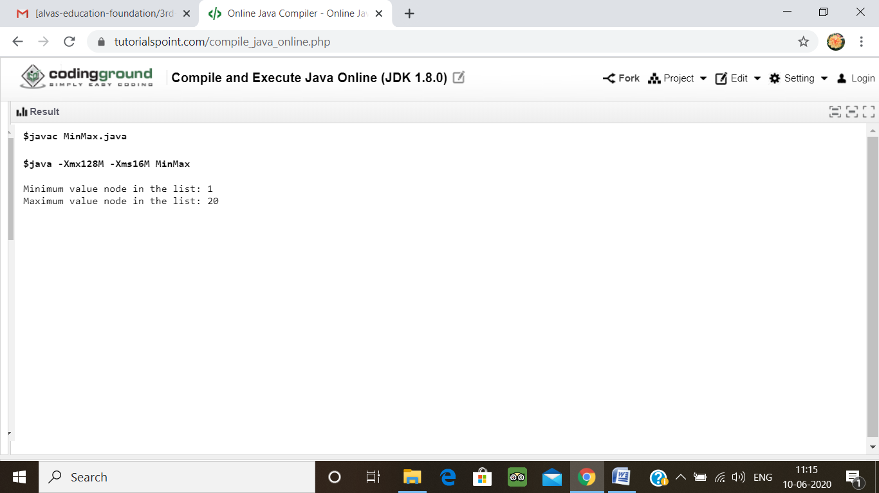

3.

